

DRAFT

Disability Access & Inclusion Plan
2026-2030

  - Subtitle

Acknowledgement
The District Council of Karoonda East Murray acknowledges that the land we meet upon is the traditional lands of the Ngarkat People, who are part of the First Peoples of the River Murray and Mallee Region.
We pay our respects to their Elders past, present and emerging and acknowledge and respect their deep spiritual and cultural connection to Country.

Contents

Message from Mayor & Elected Members 4
About us 6
Disability and Care in our Community 8
Our vision 9
Our workplace/staff 10
Strategic context 11
Disability Access and Inclusion Plan development 12
DAIP actions table 16
Domain 1: Inclusive environments and communities 16
Domain 2: Education and employment 23
Domain 3: Personal and community support 25
Domain 5: Safety, rights and justice 27
DAIP implementation 28
Glossary and Definitions 29

Message from Mayor & Elected Members
The District Council of Karoonda East Murray (the Council) is committed to ensuring that all of its residents, ratepayers, volunteers, employees and visitors can participate in the Council’s community. As a regional council, it is of fundamental importance that members of the community are able to access public facilities and services and can participate in social events. Indeed, it is this participation which fosters inclusion and contributes to the creation of a close local community. Accordingly, through various initiatives, the Council is progressively upgrading, replacing or providing new infrastructure and services to promote inclusivity and accessibility for all people and to ensure equal access to all facilities and services provided by the Council. Where practicable. This Plan aims to ensure that the region becomes more accessible for, and inclusive of, people living with a disability. It will help people within the community that are living with a disability to contribute and feel welcome, have access to services, and to participate in everyday activities.
The Council is dedicated to building a community where everyone can belong, contribute and thrive. As a regional area, it is essential that our public spaces, services and activities are accessible to all who live, work, volunteer or visit here. When people are able to take part in community life, it strengthens our connections and supports the wellbeing of our district.
Our Disability Access and Inclusion Plan (the Plan) reflects Council’s ongoing commitment to creating environments that are safe, welcoming and usable for people of all abilities. Through continuous improvement of our facilities, infrastructure and service delivery, we aim to remove barriers and expand opportunities for participation wherever possible.
This Plan sets the direction for how we will continue to support people living with disability to feel valued, included and empowered in our community. It guides us in ensuring equitable access to services, encouraging active involvement in our community and fostering a district that is accessible and inclusive.

Contact Details

District Council of Karoonda East Murray
11 Railway Terrace, Karoonda SA 5307
PO Box 58, Karoonda SA 5037
Phone: 08 8578 1004

Email: council@dckem.sa.gov.au
Website: www.dckem.sa.gov.au

This Disability Access and Inclusion Plan (DAIP) is available on www.dckem.sa.gov.au.
If you require a copy in an alternative format, (such as Easy Read or a fully accessible word version), please contact Council.
Printed copies are also available at the Council office.

About us
The District Council of Karoonda East Murray was established in 1911 and its economic base is predominantly dry land agriculture, largely based on traditional broad acre grain and wool.

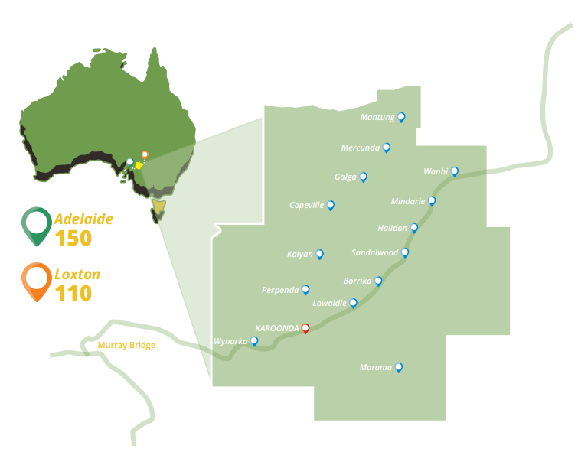
The Council covers an area of approximately 4,415 square kilometres and has an estimated population of 1,026. Located only 150kms from Adelaide and 110km from Loxton, Karoonda is referred to as “the Heart of the Mallee”. The district has an extensive road network, with some 1,168km of roads, 118km of which are sealed.

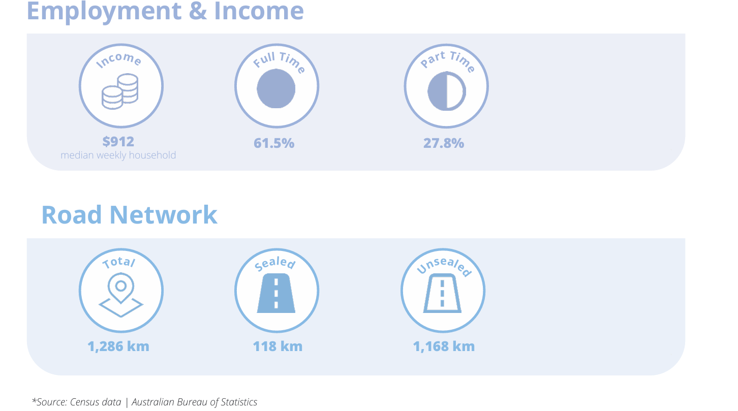
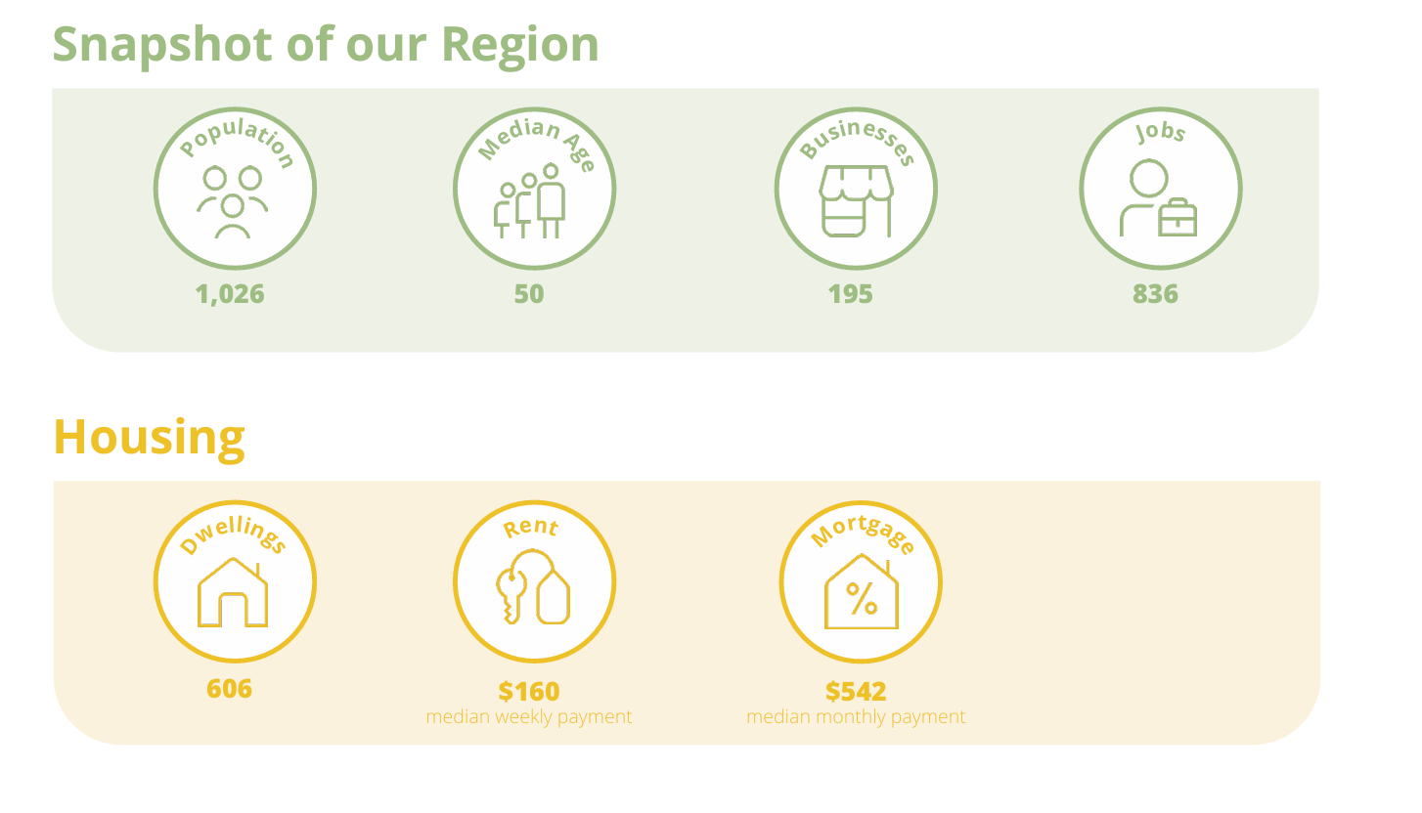

Disability and Care in our Community
Our region faces some health and care challenges, due to an ageing population and located in a rural area.
According to the 2021 Census:
- 85 people (8.4%) said they needed assistance with core activities.

- More than 56.2% of people live with a long-term health condition. These conditions may not be considered as a disability but still affect how people live and get around.

- Over 30% of residents are aged 65 or older, which means there’s more need for aged care, health services and accessible spaces.

- 14.5% of people provide unpaid care to someone with a disability. These carers play a vital role and also need support.
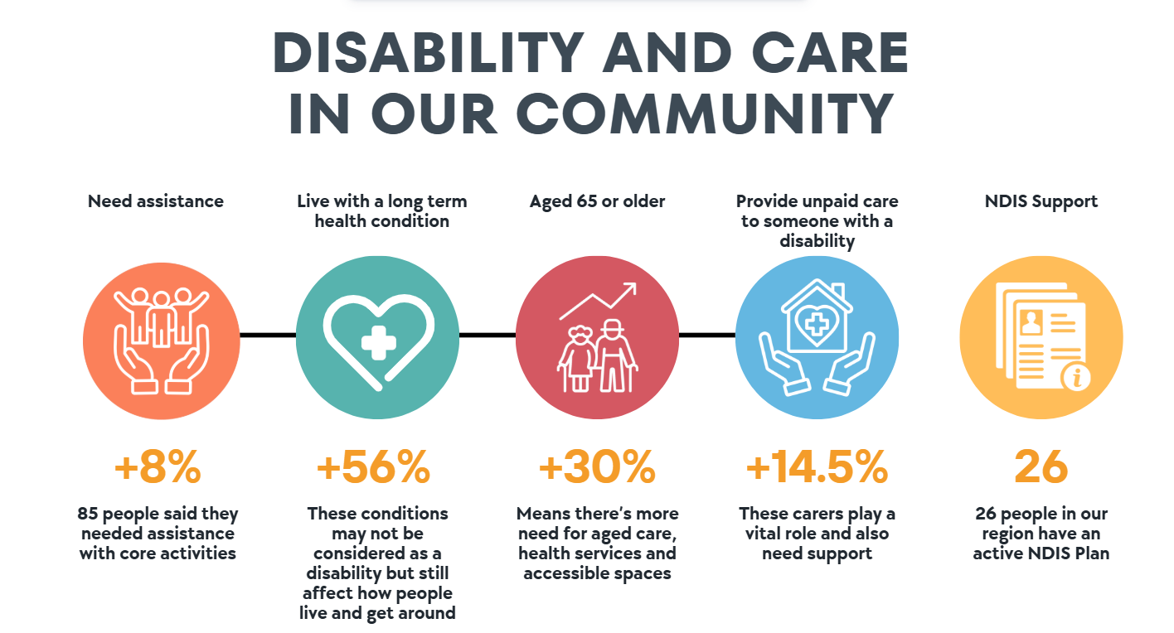
NDIS data highlights there is an ongoing need for disability support in our region with 26 people having an active NDIS plan (as at Quarter 4 / Financial Year 2024/2025).

Our vision
The South Australia State Disability Inclusion Plan is a government wide plan that sets out actions for the next four (4) years to make South Australia more accessible and inclusive. The goal is to make sure everyone has equal opportunities, and no one is left behind.

Role of Local Government
Local Government has a key responsibility in shaping communities that are inclusive and accessible for everyone. Through thoughtful planning, community engagement and the delivery of essential services, councils help create environments where all people can participate, contribute and belong.

Council’s Commitment to Access and Inclusion
The District Council of Karoonda East Murray is dedicated to building a community where people are respected, included and supported to participate fully in everyday life.
We recognise that creating an accessible and inclusive community is a shared responsibility, one that involves local action and aligns with a broader State wide commitment.
Our goal is to ensure that everyone who lives in, works in, volunteers in or visits the district can engage confidently with Council services, facilities and community activities. This Plan outlines the steps we will take to foster an environment that is welcoming, barrier free and supported by knowledgeable staff who understand and respond to diverse needs.
To achieve this, Council will:
- Enhance access to services and facilities by prioritising improvements to infrastructure, public spaces and the way we deliver services.
- Build staff capability and awareness through ongoing training and education.
- Support and encourage participation in Council programs, events and decision-making processes so that all community members, regardless of ability, feel valued and connected.
- Promote fairness and equity by upholding equal opportunity principles in all aspects of Council.

Our workplace/staff
Council has twenty-seven (27) employees (12 fulltime, 9 part-time and 6 casual) and seven (7) Elected Members.
Currently we don’t collect data on how many identify as living with a disability. However, we are committed to making our workplace accessible and inclusive for everyone.

Strategic context

State Legislation - Making South Australia More Inclusive for People with Disability
The Disability Inclusion Act 2018 was created to help make South Australia more accessible and inclusive for people living with disability.
This law supports the United Nations Convention on the Rights of Persons with Disabilities (UNCRPD), which says that people with disability have the same rights as everyone else. Australia agreed to this Convention in 2008 and signed an extra agreement (called the Optional Protocol) in 2009.

Australia’s Disability Strategy
Australia’s Disability Strategy 2021–2031 is a national plan that guides how governments across the country support people with disability. It makes sure the UN’s principles are included in policies and programs at all levels – local, state, and national.
This strategy builds on the earlier National Disability Strategy 2010–2020 and aims to keep improving the lives of people with disability over the next decade.
South Australia’s own plan, the State Disability Inclusion Plan 2025–2029, follows the goals of the national strategy and puts them into action at the state level.

State Disability Inclusion Plan
South Australia launched its first plan, called Inclusive SA, in 2019. It focused on fairness, respect, and inclusion for people with disability.
In August 2025, the updated State Disability Inclusion Plan 2025–2029 was released. It was developed with input from people who have lived experience of disability.

How This Affects Local Councils
The state plan brings together government departments and local councils to remove barriers and improve access for people with disability.
It also helps guide councils, to include disability access and inclusion in their own planning, services, and community programs.

Disability Access and Inclusion Plan development

Council’s Previous Plan Development
Council is legally required under the Disability Inclusion Act 2018 to prepare and maintain a plan that strengthens access and inclusion for people living with disability.
Our first Disability Access and Inclusion Plan, adopted in 2020, demonstrated Council’s commitment to building a more inclusive community.
This updated DAIP will continue to build on that foundation, with actions and outcomes designed to support people with physical, intellectual, sensory and psychosocial disabilities.

Consultation
When Council developed our first plan in 2020, we asked the community for feedback over a period of not less than 21 days.

Developing the new Plan
For our second plan, we considered the feedback collected during the development of the State Disability Inclusion Plan 2025–2029.
This included input from:
- People with disability
- Families and carers
- Service providers
- Advocacy groups
- The wider community
In accordance with our Public Consultation Policy, we will run another 21 days consultation period. During this time, community members, service providers and Council staff will be invited to review the draft plan and share their thoughts.

Relationship to other policies, strategies, frameworks
The District Council of Karoonda East Murray’s Disability Access and Inclusion Plan (DAIP) is closely aligned with a number of Council’s key strategic documents, including our Community Vision 2040. Together, these strategies guide how we plan, design and deliver services, infrastructure and community initiatives that support a thriving, inclusive region.

Community Vision 2040
Community Vision 2040 outlines Council’s long-term aspirations for a district that is liveable, connected, opportunistic and active. These values are reflected in six key community themes, each of which aligns with the objectives of the DAIP.
Prosperous
- A community where people and businesses can thrive, supported by inclusive opportunities and equitable access to services.
Liveable
- Welcoming people from all cultures and backgrounds, ensuring they feel part of the fabric of our community.
- Developing township Masterplans that support accessible, well-designed and inclusive public spaces.
Connected
- Strengthening community connection through accessible events, programs and activities that enable people of all abilities to participate.
Opportunistic
- Designing upgraded or new community facilities that meet the needs of diverse users.
- Building strong intergenerational connections, encouraging both younger and older residents to be active contributors to community groups and decision-making.
Active
- Supporting people of all ages and abilities to engage in recreational activities and sport.
- Maintaining and enhancing open spaces, trails and reserves to encourage healthy, inclusive community participation.
Eco-Friendly
- Managing natural resources responsibly and ensuring environmental initiatives consider and support accessibility for all community members.

Murraylands & Riverland Regional Public Health and Wellbeing Plan
The Murraylands & Riverland Regional Public Health and Wellbeing Plain guides how Councils in our region, improve health over a five (5) period, as required by the South Australian Public Health Act 2011. It has the following Strategic Priorities:
- Promote – Build stronger communities and healthier environments
- Protect – Protect against public and environmental health risks and respond to climate change
- Prevent – Prevent chronic disease, communicable disease and injury
- Progress - Strengthen the systems that support public health and wellbeing.

Other Council Policies and Strategies
The Council draws on a range of policies and legislative frameworks to promote inclusion, accessibility and the wellbeing of all community members. Key policies and legislation include:
- Emergency Management Policy
- Public Consultation Policy
- Public Interest Disclosure Policy
- Work Health and Safety & Return to Work Policy
- Risk Management Policy
- Policy Documentation Policy
- Equal Opportunity Act 1984
- Work Health and Safety Act 2012

Achievements
Since the introduction of Council’s first Disability Access & Inclusion Plan (2020–2024), significant steps have been taken to make the District Council of Karoonda East Murray more accessible and inclusive for all members of the community.
Making spaces more Accessible
- 2020/2021
  - Karoonda footpath upgrades including installation of ramps in the main street, Karoonda.
  - Footpath Bodey Street, Karoonda.
  - Upgrade to Karoonda Institute include compliant disabled toilet facilities and entrance.
  - Installation of disabled Public Toilet at Karoonda Cemetery, Wanbi Playground and Pioneer Park Karoonda.

- 2022/2023
  - Footpath upgrades on Stokes Road, West Terrace and Peake Street Karoonda

- 2023/2024
  - Footpath upgrades on Peake Street, Angus Street and East Terrace, Karoonda.

- 2024/2025
  - Footpath upgrades on North Terrace, Karoonda.

Improving Communication and Access to Information
- Notices Boards/Mail-outs: we use community notices boards and postal mail outs to make sure information reaches residents who aren’t on social media or don’t receive electronic newsletters.
- Documents: Council documents use a minimum font size of 12pt for better readability. Consideration is also given to accessibility when designing flyers and other marketing materials.

DAIP actions table

Domain 1: Inclusive environments and communities

Outcome Statement: A South Australia where all people with disability can participate as equal citizens and feel connected to their communities
Objective: To influence community attitudes to remove discrimination and build a South Australian community that values difference and respects the contributions people with disability make to our communities. This includes ensuring the community itself is fully accessible.

Priority Area 1: Active participation
Outcome: People with disability are active participants in accessible and inclusive communities.
No. | Action | State Plan Measure | Measure | Timeframe | Responsibility and data source
 | Provide training to employees and volunteers on the DHS Accessible and Inclusive Community events toolkit which will be delivered within the scope of the operational budget | 1.1.2 | The number of inclusive and accessible events, both internal and external, with 50+ people following best practice event management principles. For example, the Accessible and Inclusive Community Events Toolkit. | To be completed by March 2027.  Ongoing. | Responsibility:  Community Development / Office of the CEO  Data Source: Training attendance in Skytrust
2. | Establish and implement an internal procedure to ensure all Council managed or hosted events and activities for 50 or more people are in line with best practice event management principles which will be delivered within the scope of the operational budget. |  |  | To be implemented by June 2027. | Responsibility:  Community Development / Events & Tourism / Office of the CEO  Data Source: A copy of the procedure and number of events with which the procedure was applied.
3. | Regularly evaluate and enhance event inclusion and accessibility for people with disability at all council- led events which will be delivered within the scope of the operational budget. |  |  | To be completed by June 2028. | Responsibility:  Community Development Team  Event Coordinators  Data source:  Copy of updated checklist

Priority Area 2: Inclusive communities and attitudes
Outcome: People with disability are respected and included in their communities, where inclusive attitudes and behaviours and widely demonstrated.
No. | Action | State Plan Measure | Measure | Timeframe | Responsibility and data source
1. | Create a training log to record staff and volunteers participating in training. Record initiatives such as induction records, intranet posts, social media awareness campaigns. | 1.2.1 | The number of initiatives undertaken to promote disability inclusion and improve community attitudes towards people with disability in the community, including:  - The number of staff and volunteers participating in disability awareness training, including Universal Design. | To be completed by December 2026. | Responsibility: HR, WHS & Volunteer Management  Data source:  Skytrust reports
 | Investigate initiatives undertaken by other Councils and government agencies to promote disability inclusion and improve community attitudes towards people with disability in the community, which will be delivered within the scope of the operational budget. | 1.2.1 | The number of initiatives undertaken to promote disability inclusion and improve community attitudes towards people with disability in the community, including:  - The number of workplace initiatives promoting disability inclusion. | To be completed by December 2027. | Responsibility: HR / Office of the CEO  Data source:  Annual Report
3. | Incorporate questions in surveys that measure local community attitudes, and evaluate local community attitudes, including feedback from the disability community. | 1.2.1 |  | To be commenced by December 2026 in all surveys.  Ongoing. | Responsibility: Community Development / Marketing  Data source:  Skytrust reports
4. | Engage with Aboriginal and Torres Strait Islander agencies in the design of DAIP initiatives that reflect their lived experiences and cultural values. | 1.2.3 | The number of actions embedded in our DAIP working towards Closing the Gap targets. |  | Responsibility: Community Development  Data source: Record of number of engagement activities undertaken

Priority Area 3: Universal Design
Outcome: Everyone in South Australia can access and enjoy inclusive and accessible natural and built environments.
No. | Action | State Plan Measure | Measure | Timeframe | Responsibility and data source
1. | Undertake an audit of Council owned public facing buildings, play spaces and infrastructure, identify gaps and report on recommended modifications (e.g., signage installation, ramps, door widening). | 1.3.2 | The number of public-facing council buildings, spaces, play spaces and infrastructure that are modified to improve accessibility. For example, by adding signage or widening doors. | To be completed March 2027 | Responsibility: Assets & Infrastructure  Data Source = Copy of report
2. | Record and report on accessibility modifications to public-facing council buildings/entry, including details such as the type of modification (e.g., signage installation, door widening). | 1.3.2 |  | To be completed by December 2027 | Responsibility: Assets & Infrastructure  Data Source = Copy of report
 | Record and report on new Council-built developments, including how Universal Design principles were incorporated, which will be delivered within the scope of the operational budget. | 1.3.2 | The number of new council developments that incorporate Universal Design. | Commencing July 2026 | Responsibility: Assets & Infrastructure  Data Source = IAMP / Project Plan & Project Completion Report
 | Record and report on modifications or newly built parks, reserves, river and lake access, and playgrounds that improve accessibility, which will be delivered within the scope of the operational budget. | 1.3.3 | The number of parks, reserves, beaches and playgrounds (within these areas) that are built or modified to improve accessibility. |  | Responsibility: Assets & Infrastructure  Data Source = IAMP / Asset Register / Annual Report

Priority Area 4: Accessible facilities
Outcome: People with disability can access public toilet facilities that meet their needs when out in the community.
No. | Action | State Plan Measure | Measure | Timeframe | Responsibility and data source
1. | Report on how many Council owned toilets within the Council area meet accessibility standards or are a designed changing places facility, which will be delivered within the scope of the operational budget | 1.4.1 | The number of public council owned toilet facilities across the council area that meet accessibility standards and/or a designated Changing Places facility. | Completed by December 2027 | Responsibility: Assets & Infrastructure  Data Source = IAMP / Asset Register / Annual Report

Priority Area 5: Communications and information
Outcome: People with disability can find the information they need in the format(s) they need it in.
No. | Action | State Plan Measure | Measure | Timeframe | Responsibility and data source
1. | Provide easy read training for employees who produce public documents, information and communications related to consultation and decision making. | 1.5.1 | The number of resources or materials that have been developed in accessible formats. For example, websites that meet Web Content Accessibility Guidelines (WCAG) 2.2 level AA accessibility standard or above, Auslan translations and Easy Read documents. | Completed by June 2027 | Responsibility: Communications & marketing  Data source: Training records
2. | We will have all community engagement surveys produced in a format consisting of plain language or easy read. |  |  | Completed by June 2027 | Responsibility: Communications & marketing  Data source: Training records

Priority Area 7: Collaboration, consultation and innovation
Outcome: People with disability are actively involved in government decisions that affect their lives.
No. | Action | State Plan Measure | Measure | Timeframe | Responsibility and data source
1. | Ensure public consultations seek input from priority groups. | 1.7.1 | The number of public consultations that included and sought input from people with disability. | Commencing July 2026 | Responsibility:  Communications & Marketing  Data source:  Findings reports on consultation outcomes. Copies of Easy Read documents
2. | Use the outcomes to implement new initiatives to support Council volunteers, working groups and committee members who require assistance or workplace modifications. | 1.7.2 | The number of people with disability, including parents and carers, serving on committees and working groups.  Note: Committees are formal groups set up by councils to provide strategic advice or make decisions on disability inclusion.  Working groups are task-focused teams that address specific issues or actions supporting disability inclusion. | Commencing July 2026 | Responsibility: Governance / HR / Office of the CEO  Volunteer Management  Data Source: survey outcomes

Domain 2: Education and employment

Outcome Statement: A South Australia where all people with disability benefit from inclusive educational experiences, equitable employment opportunities and financial security

Objective: To ensure equal opportunity to learning and earning is achieved by addressing the barriers and obstacles people with disability of all ages continue to face at all levels of the education and employment experience.

Priority Area 3: Targeted transitional supports
Outcome: People with disability have supportive environments to learn, grow, and transition throughout their life.
No. | Action | State Plan Measure | Measure | Timeframe | Responsibility and data source
1. | We will provide training to relevant staff and volunteer supervisors around inclusive volunteer recruitment, the cost of which is to be determined. | 2.3.5 | The number of initiatives taken to encourage people with disability to volunteer. | Completed June 2027 | Responsibility: Volunteer Coordinator  HR & WHS  Data source: Skytrust reports

Priority Area 4: Access to employment opportunities
Outcome: People with disability have opportunities to achieve, develop and succeed in their chosen fields.
No. | Action | State Plan Measure | Measure | Timeframe | Responsibility and data source
 | Investigate initiatives undertaken by other councils and government agencies around implementing organisational changes and applying best practice to improve inclusive recruitment for people with disability, the cost of which will be delivered within the scope of the operational budget | 2.4.3 | The number of organisational changes adopted to improve inclusive recruitment for people with disability. For example, tailoring roles to fit individuals and employer incentives. | Completed by June 2027 | Responsibility:  Community Development  HR  Data source:  Report on investigations

Priority Area 5: Inclusive working environments
Outcome: People with disability have access to supportive places to earn.
No. | Action | State Plan Measure | Measure | Timeframe | Responsibility and data source
 | Establish and implement an internal procedure around adopting changes and implementing best practice around inclusive workplace practices, the cost of which will be delivered within the scope of the operational budget. | 2.5.1 | The number of workplace practices implemented to support people with disability to have equal opportunities for growth and success, including support to remain in employment. For example, outcome-based employment, flexible work arrangements, workplace adjustments and mentoring programs. | Completed by December 2027 | Responsibility:  Community Development  HR / WHS  Data source:  Report on investigations

Domain 3: Personal and community support

Outcome Statement: A South Australia where people with disability can access quality, tailored personal and community supports addressing their individual needs

Objective: To build a service system in South Australia that takes a person-centred approach that recognises the contributions and potential of all people with disability.

Priority Area 1: Accessibility
Outcome: People with disability can easily access community supports and services.
No. | Action | State Plan Measure | Measure | Timeframe | Responsibility and data source
1. | Establish and strengthen collaboration and partnerships with service providers, government and community organisations to improve access to supports and services for people with disability. | 3.1.1 | The number of council initiatives and improvements made to connect people with disability to community supports and services wherever they present. For example, referral hubs, mobile outreach, online information platforms, frontline worker training, and partnerships with community organisations. | Completed by December 2027 | Responsibility:  Community Development  Data source: record of meetings undertaken

Priority Area 5: Programs
Outcome: Government-funded programs and services include disability-specific provisions to enable full and equal participation.
No. | Action | State Plan Measure | Measure | Timeframe | Responsibility and data source
 | Review Council’s Community Grants, Sponsorship and Funding Policy and procedure to ensure applicants consider projects, events and activities are inclusive and accommodate those with disabilities, our aging population and the priority groups, the cost of which will be delivered within the scope of the operational budget. | 3.5.1 | The number of council grants and funding amount distributed to enhance disability inclusion. | Completed by December 2027 | Responsibility:  Community Development  Data source: Copy of Council’s Policy

Domain 5: Safety, rights and justice

Outcome Statement: A South Australia where all people with disability feel safe, have their rights upheld and have full and equal protection before the law

Objective: To improve the safety and overall experience of people with disability coming into contact with our emergency services, criminal justice and civil law systems.

Priority Area 2: Responding to emergencies
Outcome: People with disability are kept safe during emergencies, with their needs planned for and prioritised.
No. | Action | State Plan Measure | Measure | Timeframe | Responsibility and data source
1. | Use our communication touchpoints to promote the benefits of developing a P-CEP and help residents understand their local risks, develop personal emergency plans, and identify their support network. The cost of which is to be determined. | 5.2.1 | The number of emergency response resources and systems developed for people with disability, including the Person-Centred Emergency Preparedness (P-CEP) approach. | Completed by December 2027 | Responsibility:  Community Development  Data source:  Communications plan (TBD)

DAIP implementation
The District Council of Karoonda East Murray is committed to ensuring that the Disability Access and Inclusion Plan (DAIP) is actively implemented, monitored, and integrated into all aspects of Council operations.
- Responsibility for Delivering Actions
The Chief Executive Officer has overall responsibility for the delivery of the DAIP. Implementation of individual actions will be assigned to relevant Council staff, who will ensure initiatives are delivered effectively within their areas of responsibility.
- Sharing the Plan
The DAIP will be made publicly available on Council’s website and in printed format at Council offices. Staff will be provided with copies and briefed on its objectives and actions through internal communications and training sessions. Key stakeholders, including community groups and partner organisations, will also be informed and invited to engage with the plan.
- Embedding Disability Inclusion in Day-to-Day Operations
Council will incorporate disability inclusion principles into all service planning, infrastructure development, community engagement, and policy making.
- Monitoring and Reporting Progress
In accordance with legislation, an annual progress report will be provided to the Chief Executive – SA Department of Human Services, and a copy of the report will also be presented to Council.
This plan is a working document and can be reviewed at any time. The Plan may be reviewed in line with changing legislation.
The timeframe for evaluation and review of the Plan is four (4) years unless otherwise legislated.
- Involvement of People with Disability
People with disability will be actively engaged in the planning, review, and evaluation of DAIP initiatives. This will include opportunities to provide feedback through surveys and consultation sessions to ensure actions meet real needs and priorities.
- Promoting the DAIP
Council will promote the DAIP through public communications and social media. Promotion will highlight the importance of inclusion and encourage participation by all community members, demonstrating Council’s commitment to creating an accessible and welcoming community.

Glossary and Definitions
Disability
Refers to any condition: physical, sensory, intellectual, psychosocial, or neurological that may hinder a person’s ability to participate fully in society. This includes long-term conditions that affect everyday activities.
Access
The ability to reach, enter, use, and benefit from facilities, services, events, programs, and information, regardless of ability or disability.
Inclusion
Creating opportunities for all people to participate equally in community life, decision making, services, and activities without barriers or discrimination.
Community Participation
The ability of people with disability to engage in community activities, programs, events, and decision-making processes.
Stakeholder
Individuals, groups, or organisations with an interest in the planning, delivery, or outcomes of services, including people with disability, carers, families, advocacy groups, and staff.
Advocacy
Actions taken to support and promote the rights, needs, and inclusion of people with disability.
Equal Opportunity
The principle that all people, including those with disability, should have the same chances to access services, employment, facilities, and participate in community life.
DAIP (Disability Access and Inclusion Plan)
A formal plan developed by an organisation or council to improve access, inclusion, and participation of people with disability in programs, services, facilities, and decision making.
Compliance / Legislative Requirement
Meeting the legal obligations under disability related laws.
Engagement / Consultation
The process of involving people with disability, stakeholders and the community in planning, decision making, or evaluation to ensure their needs and perspectives are considered.
Strategic Document
A formal plan or policy that outlines an organisation’s goals, priorities, and actions, providing guidance for decision making.

Karoonda East Murray | Region summary | Data by region | Australian Bureau of Statistics
Explore data | NDIS
11-August-2020-Council-Minutes,-Confidential.pdf

